Republic of the Philippines

Laguna State Polytechnic University

Province of Laguna

***OFFICE OF STUDENT AFFAIRS AND SERVICES ANNUAL REPORT 2021***

UNITS UNDER OSAS 2021

|  |  |  |  |  |
| --- | --- | --- | --- | --- |
| **PROGRAM/ACTIVITY/**  **PROJECT** | **PERFORMANCE**  **MEASURES** | **ACCOMPLISHMENT** | **PICTORIAL** | **REMARKS** |
| ***STUDENT PUBLICATION*** | | | | |
| Coverage of the University-wide General Orientation, October 5,  2021 | 1 assigned writer submitted the article on time | 1 news article subject for the release of news letter |  | Accomplished |
| Coverage of the University-wide General Orientation, October 7,  2021 | 1 assigned writer submitted the article on time | 1 news article subject for the release of news letter |  | Accomplished |
| Coverage of SSC Election Virtual Meeting de Avance, October 10, 2021 | All assigned writers submitted the article on time | 1 news article subject for the release of news letter |  | Accomplished |

|  |  |  |  |  |
| --- | --- | --- | --- | --- |
| Announcement of New Editorial Board for Academic Year 2021-2022,  October 24, 2021 | 18 over 30 members of the publication attended the announcement of new Editorial board | Poster of Editorial Board and Staff Writers posted on page |  | Accomplished |
| The Baybay Granary Online Application for new members, October 29, 2021 | All Selection Committee participated and helped.  17 out of 21 applicants passed. | Poster of Qualified applicants and their membership itself |  | Accomplished |
| Feature of LSPU Siniloan student who placed 2nd at Agricultural and Biosystems Engineering Licensure examination, November 4 | 1 assigned writer was able to pass the article on time.  All editors were able to check and post the article on time | Feature article and a poster posted in the publication Facebook page | IMG_256 | Accomplished |

|  |  |  |  |  |
| --- | --- | --- | --- | --- |
| Online update of individual articles related to the University | Two assigned writers for each article were able to pass the assigned article on time. All editors were able to check and post the article on the desired date of posting | 11 articles in total with corresponding poster posted on publication Facebook page |  | Accomplished |
| Virtual Welcoming of the publication’s new adviser, November 29,  2021 | 36 out of 48 members of the publication were able to attend the virtual welcoming of new adviser | Welcomed the New School Paper Adviser |  | Accomplished |
| Coverage of Vaccination Drive for LSPU Siniloan students in partnership of LSPU SC and Philippine Red Cross, December 1, 2021 | All assigned members to cover the event were present. All assigned writers were able to submit on time. All editors including the adviser checked and posted the article on the same day | 1 news article and 10 photos posted on publication Facebook page | IMG_256 | Accomplished |

|  |  |  |  |  |
| --- | --- | --- | --- | --- |
| Coverage of LSPU SC 69th Founding Anniversary Activities, December 2-3,  2021 | All writers submitted the article assigned to them on time. All assigned members to cover the Day 1 were present. All assigned members to cover the Day 2 were present.  All editors including the adviser checked and posted the article on the same day | 2 news articles with corresponding photos posted on publication Facebook page |  | Accomplished |
| Coverage of LSPU SC Gender and Development (GAD) office virtual concert, December 3,  2021 | 1 assigned member submitted the article on time. All assigned members to cover the event were all present. All editors were able to check and post the article on the desired date of posting | 1 news article and corresponding photos posted on publication Facebook page | IMG_256 | Accomplished |

|  |  |  |  |  |  |  |  |  |
| --- | --- | --- | --- | --- | --- | --- | --- | --- |
| Coverage of LSPU SC 69th Founding Anniversary Competitions and Awarding, December 4-5,  2021 | All assigned writers to write and cover the event submitted the article on time. All editors were able to check and post the article on the desired date of posting | | 2 news article with corresponding photos posted on publication Facebook page | |  | | | Accomplished |
| Coverage of University- wide Choral Ensemble and Christmas Tree Decoration Contest, December 16, 2021 | 1 assigned member to write and cover the event submitted the article on time. All editors were able to check and post the article on the desired date of posting | | 1 news article and poster posted on publication Facebook page | |  | | | Accomplished |
| ***SUPREME STUDENT COUNCIL/CULTURAL SERVICES*** | | | | | | | | |
| Conducted a Vaccination | | Attended by seventy two | | The Vaccination Drive was | | C:\Users\SERIES\Documents\3RD YEAR\SSC\PICTURES\VACCINATION DRIVE\baybay 1.jpg | Accomplished | |
| Drive at St. Peter and St. | | students. | | emerged with the initiative | |  | |
| Paul Parish Church of | |  | | of the Health Services, | |  | |
| Siniloan, Laguna. December | |  | | supported by the Office of | |  | |
| 01, 2021 | |  | | the President, Vice | |  | |
|  | |  | | President, Campus | |  | |
|  | |  | | director, OSAS and SSC in | |  | |
|  | |  | | Partnership with the | |  | |
|  | |  | | Philippine Red Cross. | |  | |

|  |  |  |  |  |
| --- | --- | --- | --- | --- |
|  |  |  |  |  |
| The LSPU Siniloan Campus conducted a virtual celebration for the 69th Founding Anniversary. December 02-03, 2021 | Attended by LSPU Siniloan Campus Students together with the Nagcarlan, Lopez and Magdalena Satellite Campuses. | The LSPU Siniloan Campus conducted webinars and activities for the students. |  | Accomplished |
| The Laguna State Polytechnic University San Pablo City Campus conducted a University Wide Christmas Ensemble. December 10-16, 2021 | Attended by LSPU System Students and Faculties. | The coordinators and students from four campus attended the virtual University Wide Christmas Ensemble awarding ceremony. |  | Accomplished |

|  |  |  |  |  |
| --- | --- | --- | --- | --- |
| The Federated Supreme Student Council conducted an Oath Taking Ceremony for the Supreme Student Council A.Y 2021-2023.  December 17, 2021 | Attended by Supreme Student Council Officers of the four major campuses. | The President of Supreme Student Council from all campuses with the University President Dr. Mario R. Briones oath in LSPU San Pablo City Campus and other officers attended the virtual oath taking ceremony. |  | Accomplished |
| Conducted a Vaccination Drive for the Second Dose at St. Peter and St. Paul Parish Church of Siniloan, Laguna. December 22, 2021 | Attended by seventy two students. | The Vaccination Drive was emerged with the initiative of the Health Services, supported by the Office of the President, Vice President, Campus director, OSAS and SSC in Partnership with the Philippine Red Cross. |  | Accomplished |

|  |  |  |  |  |
| --- | --- | --- | --- | --- |
| ***HEALTH SERVICES*** | | | | |
| Monitoring LSPU Faculty and staff with COVID-19 symptoms by providing them telecare assistance and necessary monitoring with regards to their conditions, referred them to university physicians and RHU when necessary | Number of times monitored monthly | 12x  (January to December)  ) |  |  |
| Made a report with regards to the quarantine faculty and staff of LSPU | Number of reported quarantine employeesmonthly | 12x  (January to December) |  |  |
| Coordinated to RHU Sanitary officers for | Number of times coordinated | 12x  (January to December) | Thru Phone |  |

|  |  |  |  |  |
| --- | --- | --- | --- | --- |
| the Health Protocol guidelines, issuance of medical  certificate  to undergo PCR Test |  |  |  |  |
| Ensure that the health protocol was observed during the distribution of financial assistance to the scholarship grantees for the application to CHED-online portal and other school related | Number of timeshealth protocol observed | 3x |  |  |
| activities |  |  |
| Continuous coordination with respected RHU with regards to contact tracing of exposed LSPU employees and | Number of times coordinated | 12x  (January to December) | Thru Phone |  |
| proper management. |  |  |  |

|  |  |  |  |  |
| --- | --- | --- | --- | --- |
| Informed the securityofficer for all  employees’ who undergone quarantine to avoid entering the school premises as a healthprotocol | Number of  times informed | 12x  (January to December) |  |  |

|  |  |  |  |  |
| --- | --- | --- | --- | --- |
| Continuous monitoring of health protocols implementation and constant reminder tothe LSPU employee of the above- mentioned protocol by posting in GC | Number of months monitored | 12x  (January to December) |  |  |
| Coordinated with theRHU personnel for the strict implementation and observance of the COVID-19 health protocol to control the number of visitors and students entering the school premise. | Number of times coordinated | 2x |  |  |
| Coordinated with theconcerned department (HR, OSAS, Security services, InformationDesk, ICTS, Library, Scholarship grantees and Student online Appointment) for proper implementation of | Number of department s coordinated | 5 |  |  |

|  |  |  |  |  |
| --- | --- | --- | --- | --- |
| COVID-19 protocol for the scholarship  grantees. |  |  |  |  |

|  |  |  |  |  |
| --- | --- | --- | --- | --- |
| Coordinated with RHU Siniloan, Sta Maria and other respected RHU withregards to the request of allocatedvaccines | Number of times coordinated | 6x  (July to December) |  |  |
| Coordinated with the MHO of Sta.  Maria with regards towilling students to get vaccinated ages (8 years old and above) for Sta. Maria residents. | Number of times coordinated | 2x  Jan to Nov | Thru Phone |  |
| Updating the list of vaccination and unvaccinated employees of LSPU-SC as part of the memo of CHED | Number of  times updated | 4x (Aug- Dec) |  |  |

|  |  |  |  |  |
| --- | --- | --- | --- | --- |
| Assisted the LSPU employees for theirschedule of vaccination | Number of  times assisted | Once (1) |  |  |
| Attended various meeting with regardsto the ISO preparation | Number of times attended the meeting | 5x |  |  |
| Attended 2 daysLSPU-ISO Audit Recertification | Number of times attended audit recertification | 2x |  |  |

|  |  |  |  |  |
| --- | --- | --- | --- | --- |
| Inspection and supervision of SchoolSanitation | Number of times inspected and supervised | 12x  (January to December) |  |  |
| Supervised the utilityfor the disinfection of rooms within the school premises | Number of times supervised | 4x (September to October) |  |  |

|  |  |  |  |  |
| --- | --- | --- | --- | --- |
| Coordinated with theRHU Sanitary Officer with regards to LSPU Campus area with a lot of mosquitoes and asked for their recommendation andassistance for the  said matter | Number of times coordinated | 3x |  |  |
| Inspected a  construction site and made a communication letterfor the contractor of LSPU, requesting a medical certificate of the workers to be secured before the start of construction | Number of times made communication | 2x |  |  |
| Attended different online meetings andwebinar for professional growthand advancement | Number of months attendedonline meetings and webinar | 12x (January to Dec) |  |  |

|  |  |  |  |  |
| --- | --- | --- | --- | --- |
| Made quarterly request letter for medical supplies and equipment and disinfectants solution | Number of times make a request letter | 4x/year |  |  |
| Solicitation and coordination with regards to the donation of medicines for LSPU-SC  employees | Number of times solicited and coordinate | 2x |  |  |
| Distribution of donated medicinesto all in need employees of LSPU | Number of times Distributed | 2x (Jan - Feb) |  |  |
| Coordination with RHU sanitary officersfor the donation of medicines from PHILRADS | Number of times coordinated | Once (1) |  |  |

|  |  |  |  |  |
| --- | --- | --- | --- | --- |
|  |  |  |  |  |
| Intensified  information for themonthly health awareness | Number of Intensified informatio n | 12x (Jan to Dec) |  |  |
| Attended quarterly meeting of LSPU Nurses with regardsto plan of activities for 2021 | Number of  times attended | once |  | Due to pandemic instead of havingface to face, we made it virtual. |

|  |  |  |  |  |
| --- | --- | --- | --- | --- |
| Attended zoom meeting with myco-nurses | Number of timesattended | 6x |  |  |
| Coordinated with themunicipal health officers of RHU- Siniloan with regardsto the distribution of donated medicines | Number of times Coordinated | 2x |  |  |
| Distribution of medical forms to be used for their AnnualPhysical Exam of the reporting employeesof LSPU- SC on March8, 2021 at the Medical Clinic | Number of times distributed medicalforms | 4x |  |  |

|  |  |  |  |  |
| --- | --- | --- | --- | --- |
| Facilitated medical examination for faculty | Number of timesfacilitated | Once/mont h(Feb- Mar) |  |  |
| Provided emergency assistance and first aid treatment to LSPU employees when necessary | Number of times firstaid treatment given | 12x (Jan to Dec) |  |  |
| Coordinated with theconcerned department (HR, OSAS, Security services, InformationDesk, ICTS, Library, Scholarship grantees and Student online Appointment) for proper implementation of COVID-19 protocol for the scholarship  grantees. | Number of department s coordinated | 5 |  |  |

|  |  |  |  |  |
| --- | --- | --- | --- | --- |
| Referral thru the University Physicianof all medical concerns of faculty and staff of LSPU from time to time. | Number of times referred(weekl y) | 4x/week |  |  |
| Coordinated with thePPSD chairperson and Supervise the Utility for disinfection | Number of times supervised the utilitymonthly | 4x/month |  |  |
| Giving online  instruction from timeto time to my clinic staff to ensure the continuous service ofLSPU clinic while on Skeletal work arrangement | Number of timesgiven online instruction | 6x |  |  |

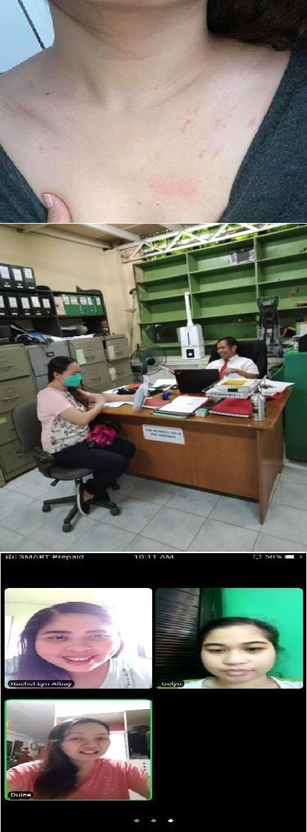

|  |  |  |  |  |
| --- | --- | --- | --- | --- |
| Coordinated with ICTS Chairperson forthe things to be prepared for the ergonomics webinarand other necessaryactivities  Coordinated with ICTSchairperson for the enhancement/ purchase of improved electronic temperature  monitoring at the entrance area | Number of times coordinated  Number of times coordinated | 5x  3x |  |  |
| Attended and participated on thewebinar entitled ergonomics | Number of times attended this webinar | Once (1) | April 30 |  |

|  |  |  |  |  |
| --- | --- | --- | --- | --- |
| Attended and participated zoom meeting for COPC presentation virtualvisit with concernedunits | Number of Department undergone COPC | 8 |  | 8 college department exceptsenior high school |

|  |  |  |  |  |
| --- | --- | --- | --- | --- |
|  |  |  |  |  |
| Coordinated with thePHO personnel to thematerials and flyers to be used for  COVID-19  information Dissemination Campaign and otherHealth  Activities | Number of times coordinated | 2x |  |  |
| Coordinated with theadmin officials of Stamaria together with the extension chairperson and participated in providing flexible learning with the useof e-learning bus to different barangays | Number of times Coordinated  Number of times Participated | Once (1)  3x |  | 2-Sta. Maria1- Kapatalan |

|  |  |  |  |  |
| --- | --- | --- | --- | --- |
| Assisted the Scientiain collecting water samples from different sources | Number of times ofwater sampling | 2x |  | May- 1  April- 1 |
| Coordinated with the contact tracer ofRHU Siniloan and signed a consent waiver for the  “Presidential  Management Staff” | Number of times coordinated | Once (1) |  |  |

|  |  |  |  |  |
| --- | --- | --- | --- | --- |
| Assisted the  medical doctor andproviding medical certification and consultation for LSPU employees and students | Number of days conducted Annual medical examination | 4x an d  as necessary |  | Unable to continuedue to COVID-19  Lockdown |
| Made certificationof defective equipment | Number of times made certification | 5x |  |  |

|  |  |  |  |  |
| --- | --- | --- | --- | --- |
| Monitored  remaining stocks available of disinfectants solutions at supplyoffice | Number of timesmonitored | 9x (Jan- Nov) |  |  |
| Attended LPSU Virtual Orientation campus wide | Number of timesattended | Once (1) |  |  |
| Facilitated flu  vaccination of LSPUemployees permanent and casual teaching andnon-teaching  employees | Number of times facilitated the FluVaccination | 3x (Oct- Dec) |  |  |

|  |  |  |  |  |
| --- | --- | --- | --- | --- |
| Participated from different colleges for the submissionof requirements needed for accreditation | Number of times participated | 3x (Oct to Dec) |  |  |
| Participated in theshooting for the LSPU COVID-  19 vaccination Strategies to encouraged students to the  vaccinated | Number of times participated | 4x |  |  |
| Submitted report on retrofitted facilities and healthprotocol compliance with picture for the preparation of face-to face classes as mandated by the CHED | Number of timessubmitted | once |  |  |

|  |  |  |  |  |
| --- | --- | --- | --- | --- |
| Coordinated with the PPSD director atSta. Cruz Campus with regards to the needs to be prepared for the upcoming face to face classes | Number of times coordinated | Once (1) |  |  |
| Coordinated with the RED Cross vaccination coordinator with regards to the planof COVID vaccination drive for LSPU students aged 18 years old and above | Number of times coordinated | 6x |  |  |

|  |  |  |  |  |
| --- | --- | --- | --- | --- |
| Participated and Conducted Vaccination Drive incollaboration with RHU and Red Cross | Number of timesfacilitated and conducted | Once (1) |  |  |
| ***GUIDANCE AND COUNSELING ADMISSION AND TESTING UNIT*** | | | | |

|  |  |  |  |  |
| --- | --- | --- | --- | --- |
| University wide Meeting OSAS **January 11, 2021** | All units of OSAS |  |  | Accomplished |

|  |  |  |  |  |  |
| --- | --- | --- | --- | --- | --- |
| Meeting with co – counselors for the preparation of university wide webinar on online class  **January 15, 2021** | LSPU System Guidance Counselors |  |  | | Accomplished |
| LSPU – SC webinar pre orientation and pre- registration of potential members  **January 27, 2021** | LSPU FEA Members |  |  | | Accomplished |
|  |  |
|  | |

|  |  |  |  |  |  |
| --- | --- | --- | --- | --- | --- |
| COPC BS Agricultural Biosystems Engineering  **January 28, 2021** | CIDQA / COE/ LSPU  Administration |  | *No picture available* | | Accomplished |
| Meeting counselors, ICTS for the conduct of university wide webinar  **February 3, 2021**  Webinar: Gate Pass Filing and Approval et al  **February 10, 2021** | LSPU Counselors and ICTS  LSPU Siniloan Employees and ICTS |  |  |  | Accomplished  Accomplished |
|  | |

|  |  |  |  |  |
| --- | --- | --- | --- | --- |
| Webinar on e- Preparation, e- Packaging and Content Coaching for Program Accreditation  **February 10, 2021** | ICTS and Colleges in-charged for Accreditation, IQA |  |  | Accomplished |
| LSPU university wide webinar: Mind your net: LSPU webinar on online class.  **February 15, 2021** | LSPU System Guidance Counselors, Students and ICTS office |  |  | Accomplished |

|  |  |  |  |  |
| --- | --- | --- | --- | --- |
| Meeting on Admission for AY 2021 – 2022  **February 23, 2021** | Counselors /ICTS LSPU –  San Pablo |  |  | Accomplished |
| COPC BS Criminology  **March 11, 2021**  COPC BS Psychology  **March 19, 2021** | QA/CCJE/ICTS /Admin staff  QA/CAS/ICTS/ Admin staff |  | *No picture available* | Accomplished  Accomplished |

|  |  |  |  |  |
| --- | --- | --- | --- | --- |
| COPC BSEd  **March 22, 2021** | QA/CTE/ICTS/ Admin staff |  | *No picture available* | Accomplished |
| Orientation for BS Psychology Students  **March 24, 2021**  Release good moral certificates  **January – March 2021** | 4th year BS Psychology Students , Program Coordinator, Dean CAS, Guidance Counselor  Guidance Staff | 211 Good moral certificates released | *No picture available* | Accomplished  Accomplished |
| Signed Clearance  **January – March 2021** | Guidance Staff | 335 signed clearances | *No picture available* | Accomplished |
| Needs Assessment survey  **January – March 2021** | Guidance Staff | 90 Responses | *No picture available* | Accomplished |

|  |  |  |  |  |
| --- | --- | --- | --- | --- |
| Tele counselling  **January – March 2021** | Guidance Counselor | 4 clients | *No picture available* | Accomplished |
| University wide Meeting for admission **April 23, 2021** | All offices concern with admission |  |  | Accomplished |
| Meeting /training for admission  **April 30 2021** | All offices concern with admission |  |  | Accomplished |

|  |  |  |  |  |
| --- | --- | --- | --- | --- |
| Training online admission **May 3, 2021**  Finalization of online system for admission  **May 5, 2021** | Guidance Counselors  All offices concern |  |  | Accomplished  Accomplished |

|  |  |  |  |  |
| --- | --- | --- | --- | --- |
| Meeting with Satellite Campuses administrator/ OIC for online admission  **May 7, 2021** | Satellite Campus administrator/ OIC/ Guidance Counselors |  |  | Accomplished |
| Admission Officer’s  meeting  **May 17, 2021** | Admission Officer |  |  | Accomplished |

Mental health policy manual brain storming

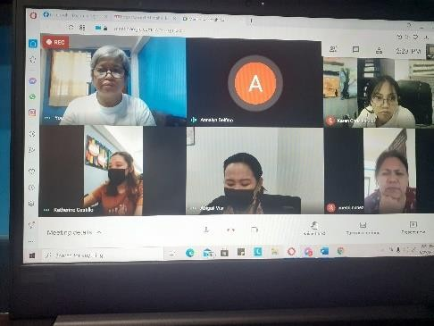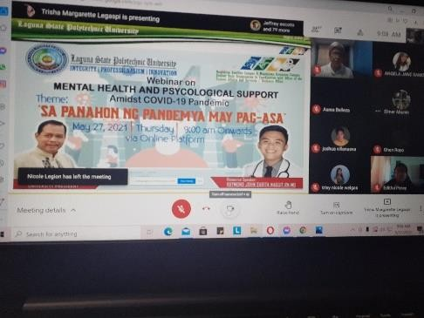

# May 25, 2021

Webinar: Mental Health and Psychological Support Sa Panahon ng Pandemya may Pag –asa

# May 27, 2021

Guidance Staff

Students of Nagcarlan and Magdalena Satellite Campus

Accomplished

Accomplished

|  |  |  |  |  |
| --- | --- | --- | --- | --- |
| Webinar: Social and Media Literacy |  |  |  |  |
| **May 28,2021** |  |  |
|  | CTE – Students |  |
|  |  | Accomplished |
| Admission meeting with Senior Officials |  |  |
| **June 3, 2021** | Senior Officials, Deans/ Associate Deans/Guidance Counselors/ICTS/NETLINK | Accomplished |

|  |  |  |  |  |  |
| --- | --- | --- | --- | --- | --- |
| Meeting with VPAA Dr.  Eden Callo for the mental health policy manual  **June 7, 2021** | VPAA/ Health Officer/Guidance Counselors |  |  | | Accomplished |
| Meeting with NETLINK: Updating online admission  **June 18, 2021** | Guidance Counselors/ ICTS/NETLINK |  |  | | Accomplished |
|  |  |
|  | |

|  |  |  |  |  |
| --- | --- | --- | --- | --- |
| COPC: BS Accountancy, BS Business Administration and BS Office Administration  **June 16, 2021** | CHED Panel of evaluators, Dean/Associate Deans/ Faculty / Guidance Counselor/ Non - teaching Staff |  |  | Accomplished |
| COPC : BS Computer Science, BS Information Technology and BS Information System  **June 18, 2021** | CHED Panel of evaluators, Dean/Associate Deans/ Faculty / Guidance Counselor/ Non-teaching Staff |  |  | Accomplished |

|  |  |  |  |  |
| --- | --- | --- | --- | --- |
| University wide Academic Council Meeting:  A Proposal of the mental health policy manual  **June 21, 2021**  Webinar on Guided Imagery  **June 29, 2021** | VPAA , Faculty and Non- teaching personnel related to academics  Counselors and mental health practitioners |  |  | Accomplished  Accomplished |

|  |  |  |  |  |  |
| --- | --- | --- | --- | --- | --- |
| Issuance of Good moral certificate  **April – June 2021** | Guidance Staff/students | 151 good moral certificates release | No picture available | | Accomplished |
| Signed Clearance  **April – June 2021** | Guidance Staff/students | 55 signed clearances | No picture available | | Accomplished |
| Counseling ( web Counseling)  **April – June 2021**  Examination for non- teaching personnel  July 2021 | Guidance Counselor  Guidance counselor/non- teaching personnel / HR | 5 clients | No picture available | | Accomplished  Accomplished |
|  |  |
|  | |

|  |  |  |  |  |
| --- | --- | --- | --- | --- |
|  |  |  |  |  |
| Academic Council Meeting  **August 4, 2021** | All members of academic council |  |  | Accomplished |

|  |  |  |  |  |
| --- | --- | --- | --- | --- |
| E-counseling  **August 11, 2021** | Parent/teacher/ student/guidance counselor |  |  | Accomplished |
| E-counseling  **August 12, 2021** | Parent/teacher/ student/guidance counselor |  |  | Accomplished |

|  |  |  |  |  |  |  |
| --- | --- | --- | --- | --- | --- | --- |
| Monitoring, checking and approving of online applications  **July – September 2021** | Guidance Staff |  |  | | | Accomplished |
| Meeting with NETLINK:  Updating online admission **August 26, 2021**  University wide meeting with OSAS  **September 10, 2021** | Guidance Counselors/ ICTS/NETLINK  All unit heads under OSAS |  |  |  |  | Accomplished  Accomplished |
|  | | |

Meeting with the Guidance counselors in preparation to ISO audit.

# September 13, 2021

Meeting with the Guidance counselors for ISO audit compliance

# September 20, 2021

Guidance counselors and staff

Guidance counselors and staff

Accomplished

Accomplished

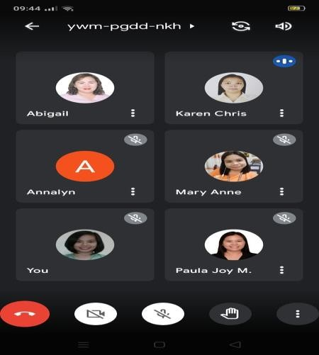

Follow up meeting with the guidance counselors and staff for ISO audit compliance

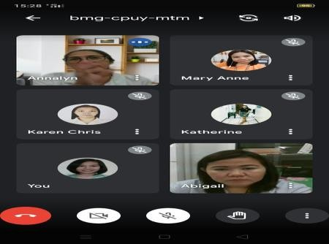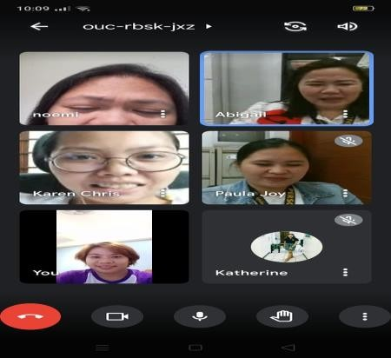

# September 24, 2021

Guidance counselors and staff

Accomplished

|  |  |  |  |  |
| --- | --- | --- | --- | --- |
| Issuance of Good moral certificate  **July - September 2021** | Guidance Staff/students | 44 Good moral certificates issued | No picture available | Accomplished |
| Signing of Clearance  **July - September 2021** | Guidance Staff/students | 40 clearances signed | No picture available | Accomplished |
| LSPU Siniloan Virtual Orientation  **October 7, 2021** | OSAS Units, students and administration |  |  | Accomplished |
| ISO Audit October 19-20, 2021 | QA and Offices concerned |  | No picture available | Accomplished |

|  |  |  |  |  |  |
| --- | --- | --- | --- | --- | --- |
| Graduate Studies and Applied Research (GSAR) Virtual Orientation **October 28, 2021** | CTE-GSAR, GSAR students |  |  | | Accomplished |
|  |  |
|  | |
| Training for Online Accreditation System (OAS)  **November 2, 2021** | ICTS Office, QA and Offices concerned |  |  | | Accomplished |

|  |  |  |  |  |
| --- | --- | --- | --- | --- |
| Meeting for 69th Founding Anniversary of LSPU Siniloan **November 4, 2021** | OSAS, OSAS Units and Offices Concerned |  |  | Accomplished |
| COPC of BS Agriculture  **November 12, 2021** | College of Agriculture, QA and other concerned offices | Accomplished |

|  |  |  |  |  |
| --- | --- | --- | --- | --- |
|  |  |  |  |  |
| Meeting of LSPU System Guidance Counselors **November 15, 2021** | Guidance Counselors LSPU System |  |  | Accomplished |

|  |  |  |  |  |  |
| --- | --- | --- | --- | --- | --- |
| Mental Health Webinar on Founding Anniversary **December 3, 2021** | OSAS, Guidance Office, CCS and Peer Facilitators |  |  | | Accomplished |
| EPI Examination for CTE Students  **December 3-10, 2021** | CTE 4th year students, Guidance office |  |  | | Accomplished |
|  |  |
|  | |

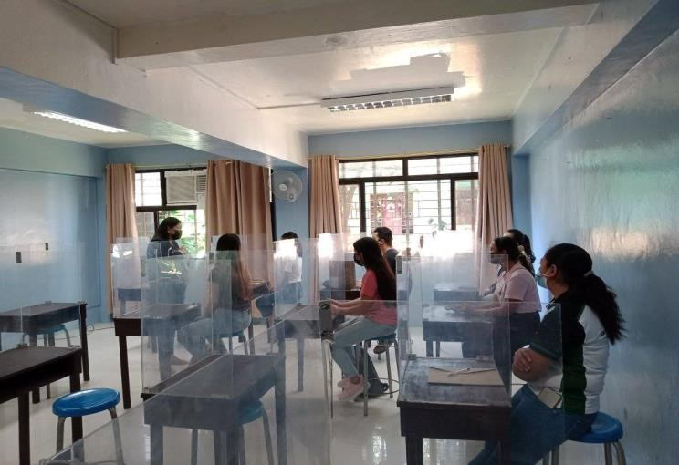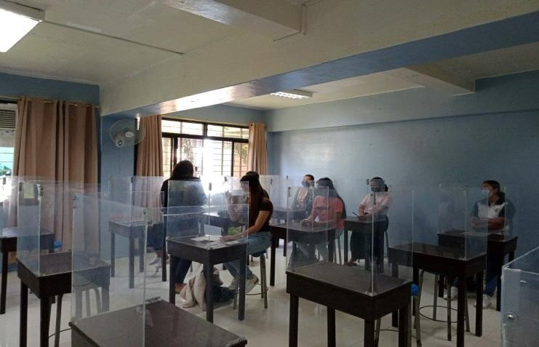

Accomplished

|  |  |  |  |  |
| --- | --- | --- | --- | --- |
|  |  |  |  |  |
| GAD Webinar for NTEA RA 11313: Safe Spaces Act (Bawal Bastos Law)  **December 14, 2021** | NTEA Members and GAD Office |  |  | Accomplished |

|  |  |  |  |  |
| --- | --- | --- | --- | --- |
| Issuance of Good moral certificate  **October - December**  **2021** | Guidance Staff/ Students | 32 good moral certificates released | No picture available | Accomplished |
| Signing of Clearance  **October - December 2021** | Guidance Staff/ Students | 40 signed clearances | No picture available | Accomplished |

***SCHOLARSHIP AND FINANCIAL ASSISTANCE UNIT***

|  |  |  |  |  |
| --- | --- | --- | --- | --- |
| VIRTUAL LAUNCH EVENT OF LANDBANK TES MASTERCARD | CHEDRO IV-A Officials and Staff, SUC’s, LUC’s and TES Scholars | Participated the Virtual Launch Event of Landbank TES Mastercard via FB Live |  | **Accomplished** |
| **(**January 15, 2021) |  |  |  |
| RELEASE OF TES STIPEND ALLOWANCE | Chairperson, Cashier’s Office, SFA Staff, and Scholars | Assisted scholars during the release of TES Stipend Allowance |  | **Accomplished** |
| (February 8-9, 2021) |  |  |  |
| WEBINAR: LSPU RECORDS MANAGEMENT AND DIGITIZATION  (February 18, 2021) | All Unit Heads, Job Orders, Part-Time and Regular, Faculty, Casual/ Permanent, Non-Teaching Employees | Attended Webinar: LSPU Records Management and Digitization |  | **Accomplished** |

|  |  |  |  |  |  |
| --- | --- | --- | --- | --- | --- |
| VIRTUAL MEETING RE: ORIENTATION ON THE IMPLEMENTATION OF LANDBANK TES MASTER CARD PREPAID CARD (LMPC) | TES Focal Person, Accountant, Chairpersons and Staff | Attended Virtual Meeting Re: Orientation on the Implementation of Landbank Tes Master Card Prepaid Card (Lmpc) |  | **Accomplished** | |
| (February 23,202) |  |  |  | |
| RELEASE OF STIPEND ALLOWANCE AND ORIENTATION OF TES LANDBANK MASTER CARD FOR TES GRANTEES | Chairperson, SFA Staff, Scholars | Assisted scholars during the release of TES Stipend Allowance |  | **Accomplished** | |
| (March 8, 10,15, and  17, 2021) |  |  |  | |
| ORIENTATION IN MAGDALENA CAMPUS |  | Attended and participated the Orientation of Magdalena Campus as speaker | C:\Users\LSPU-SCHOLARSHIP\Downloads\181472140_364219778360368_4994431580204482087_n.png | **Accomplished** | |
| **(**May 4, 2021) |  |  | |
| ASSISTING THE SCHOLARS DURING THE RELEASE OF | Chairperson, Cashier’s Office, SFA Staff, and Scholars | Assisted scholars during the release of TES-TDP Stipend Allowance |  | **Accomplished** |  |

|  |  |  |  |  |  |
| --- | --- | --- | --- | --- | --- |
| TES-TDP ALLOWANCE  (June 9-11,2021) | |  |  | C:\Users\LSPU-SCHOLARSHIP\Downloads\261855786_605224450712330_1929022482314793972_n.png |  |
|  | |  |  |  | **Accomplished** |
| ASSISTING THE SCHOLARS DURING THE RELEASE OF TES-TDP ALLOWANCE | | Chairperson, Cashier’s Office, SFA Staff, and Scholars | Assisted scholars during the release of TES Stipend Allowance |  |
| **(**June 14-16, 2021) | |  |  |  |
|  | |  |  | C:\Users\LSPU-SCHOLARSHIP\Downloads\228807473_2638468059787825_6694132805727893298_n.png | **Accomplished** |
| RE-ORIENTATION FOR ISO RECERTIFICATION | | LSPU IQA, LSPU Top  Management, and Unit Heads | Attended the Re-Orientation for ISO Recertification |  |
| (August 4, 2021) | |  |  |  |
| MEETING OF OSAS UNIT  (August 10, 2021) | OSAS Director and Unit Heads | | Attended the OSAS meeting | C:\Users\LSPU-SCHOLARSHIP\Downloads\241447691_396375718569595_140898413328337255_n.png | **Accomplished** |
|  |  | |  |  |  |

|  |  |  |  |  |
| --- | --- | --- | --- | --- |
| ISO Internal IQA Visit | LSPU IQA, LSPU Top  Management, and Unit Heads | Participated the ISO Internal IQA Visit | C:\Users\LSPU-SCHOLARSHIP\Downloads\242345786_1445152839192352_4687608709223108079_n.png | **Accomplished** |
| **(**September 15,  2021) |  |  |  |
| ANNUAL REVIEW | CHEDRO IV-A Official | Participated the Annual Review |  |  |
| AND ASSESSMENT | and Staff, Region IV-A | and Assessment of LSPU Strategic |  |
| OF LSPU STRATEGIC | CALABARZON SUC’s and | Development Plan 2020 | **Accomplished** |
| DEVELOPMENT | LUC’s TES/TDP Focal |  |  |
| PLAN 2020 | Persons |  |  |
| (September 22-24, |  |  |  |
| 2021) |  |  |  |
| ATTENDING ISO ASSESSMENT  (September 29,  2021) 8am-5pm | LSPU IQA, LSPU Top  Management, and Unit Heads | Participated the ISO Assessment/Audit | C:\Users\LSPU-SCHOLARSHIP\Downloads\262202259_1229248320897871_2081539077311512380_n.jpg | **Accomplished** |
| 3RD PROVINCIAL ADVISORY COMMITTEE (PAC) MEETING | DSWD and PAC Members of IV-A CALABARZON | Attended 3RD Provincial Advisory Committee (Pac) Meeting |  |
| (September 29,  2021) 9-12nn |  |  |  |

|  |  |  |  |  |
| --- | --- | --- | --- | --- |
| CHED TES MEETING | CHEDRO IV-A Official | Attended CHED TES Meeting |  | **Accomplished** |
|  | and Staff, Region IV-A |  |  |
| (October 13, 2021) | CALABARZON SUC’s and |  |  |
|  | LUC’s TES Focal Persons |  |  |
| ACADEMIC COUNCIL MEETING  (October 14, 2021) | VP’s and Academic  Council Members | Attended Academic Council Meeting |  | **Accomplished** |
| ISO REMOTE FOLLOW- UP AUDIT  (October 18-19,  2021) | TUV-R Auditors, LSPU Top Management, and Unit Heads | Participated during the TUV-R ISO Remote Follow-Up Audit | C:\Users\SANDY JESSIE LYNN\Downloads\245165336_214533033962881_1915098738715908646_n.png | **Accomplished** |
| RELEASE OF TES- TDP (BATCH 2) STIPEND ALLOWANCE FOR A.Y. 2019-2020 | Chairperson, Cashier’s Office, SFA Staff, and Scholars | Assisted scholars during the release of TES Stipend Allowance | DSC_1279 | **Accomplished** |
| (October 25-28,  2021) |  |  |  |

|  |  |  |  |  |
| --- | --- | --- | --- | --- |
| ADMIN COUNCIL MEETING | LSPU SC Campus Director and Admin Council Meeting | Attended Academic Council Meeting |  | **Accomplished** |
| CHED TES-TDP MEETING  (November 12,  2021) | CHEDRO IV-A Official and Staff, Region IV-A  CALABARZON SUC’s and  LUC’s TES/TDP Focal  Persons | Attended CHED TES-TDPMeeting |  | **Accomplished** |
| CHED CSP MEETING  (November 15,  2021) | CHEDRO IV-A Official and Staff, Region IV-A  CALABARZON SUC’s and  LUC’s TES/TDP Focal  Persons | Attended CHED CSP Meeting |  | **Accomplished** |
| CHED TES-TDP COORDINATION MEETING  (November 17, 202) | CHEDRO IV-A Official and Staff, Region IV-A  CALABARZON SUC’s and  LUC’s TES/TDP Focal  Persons | Attended CHED TES-TDP Coordination Meeting |  | **Accomplished** |
| INTERVIEW FOR PUREGOLD SCHOLARS APPLICANT  (November 24,  2021) | Puregold Staff, Student/Applicant for scholarship and SFA SC Chairperson | Assisted the student-applicants during their interview | C:\Users\LSPU-SCHOLARSHIP\Downloads\260235110_935636253993711_7881536785772365748_n.png | **Accomplished** |

|  |  |  |  |  |
| --- | --- | --- | --- | --- |
| RELEASE OF TES (BATCH 1 AND 2) STIPEND ALLOWANCE FOR FIRST SEMESTER A.Y. 2020-2021  (December 1-2,  2021) | Chairperson, SFA Staff, Scholars | Attended CHED TES Coordination Meeting |  | **Accomplished** |
| RELEASE OF TES (BATCH 1 AND 2) STIPEND ALLOWANCE FOR FIRST SEMESTER A.Y. 2020-2021  (December 1-2,  2021) | Chairperson, Cashier’s Office, SFA Staff, and Scholars | Attended CHED TES-TDP Coordination Meeting |  | **Accomplished** |
| MEETING FOR OUTSTANDING BALANCE OF FUND TRANSFER (MORNING)  (December 3, 2021) | Chairperson, SFA Staff, and accounting staff | Attended Meeting RE: Outstanding balance of fund Transfer |  | **Accomplished** |

|  |  |  |  |  |
| --- | --- | --- | --- | --- |
| CHED COORDINATION MEETING ON THE SUBMISSION OF TES AND TES-TDP REQUIREMENTS A.Y. 2019-2020 (AFTERNOON)  (December 3, 2021) | Chairperson, SFA Staff, and accounting staff | Attended Coordination Meeting on submission of CHED TES and TES-TDP |  | **Accomplished** |
| RELEASE OF TES (BATCH 3 AND 4) STIPEND ALLOWANCE FOR FIRST SEMESTER A.Y. 2020-2021  (December 6-7,  2021) | Chairperson, Cashier’s Office, SFA Staff, and Scholars | Assisted scholars during the release of TES Stipend Allowance |  | **Accomplished** |
| RELEASE OF TES- TDP (BATCH 1-10 ) STIPEND ALLOWANCE FOR FIRST SEMESTER A.Y. 2020-2021  (December 16-17,  2021) | Chairperson, Cashier’s Office, SFA Staff, and Scholars | Assisted scholars during the release of TES-TDP Stipend Allowance for First Semester A.Y. 2020-2021 |  | **Accomplished** |

|  |  |  |  |  |
| --- | --- | --- | --- | --- |
| ***STUDENT ORGANIZATION AND ACTIVITIES*** | | | | |
| Meeting with SBO and Society advisers from all colleges or department. | Number of Attendees | The meeting was held last October 28, 2021 – 1PM. There were 28 attendees. |  | Accomplished |
| Submission of documents for accreditation of old and new SBO and society. | Number of SBO and society who submitted their documents | Number of SBO who passed their documents: 9  Number of society who passed their documents: 14  SBO and society from COE were still processing and completing their documents. |  |  |

|  |  |  |  |  |
| --- | --- | --- | --- | --- |
| Online checking of documents submitted documents for accreditation and recognition of new and old SBO and society. | Number of SBO and society whose documents were already checked | Number of SBO who were able to attend the online checking: 5  Number of society who were able to attend the online checking: 5 |  |  |
| Recognition of SBO and society. | Number of recognized SBO and society | 3 recognized SBO and society | *-* |  |

|  |  |  |  |  |  |
| --- | --- | --- | --- | --- | --- |
| ***SECURITY & MANAGEMENT OFFICE*** | | | | | |
| Issuance of Gate Pass | Number of issued Gate Pass / Number of issued visitors x100 | Complied in the implementation of vehicle car pass through employees/ faculty/ students and visitors as per Board Resolution No. 398  S-2004 |  | Accomplished |  |
| Accomodation | Number of Approved Request Letter | Received approved request letter by the Admin officials and accommodate incoming visitors in the campus with request letter and assist them where to go |  | Accomplished |

|  |  |  |  |  |
| --- | --- | --- | --- | --- |
| Monitoring | Number of monitor incoming and outgoing vehicle | Monitor the incoming and outgoing vehicle inside the campus included employees , students and visitors , Employees through pass slip, travel order and trip ticket |  | Accomplished |

|  |  |  |  |  |
| --- | --- | --- | --- | --- |
| Surveillance audit ISSO 9001-2015 | Number of requirements and documents | Complied all requirements needed in the certification for ISSO.  Complete all papers and documents required and needed. |  | Accomplished |
| Reports | Number of incident and spot reports | Response submitted report by the guard on duty.  Referred to the authorized person concern regarding the incidents happen or refer to the authority for further action |  | Accomplished |
| Evaluate the performance of Security Guards | 100% performance of organic and job order security | Satisfaction rating sheet for security personnel |  | Accomplished |

|  |  |  |  |  |
| --- | --- | --- | --- | --- |
| Respond inquiries and provide information to clientele concern and queries through telephone | 99% responded to inquiries | Create documentation regarding the inquiries made by the client and response answered by the SMO. |  | Accomplished |
| Provide immediate response through communication handheldradio. | 99% immediate respond to | Logbook licensed user and operator |  | Accomplished |
| Provide safety to the faculty, staff and client and facilities of the Laguna State Polytechnic University | 100% of faculty will provide health safety protocols provided by the SMO | Provide health protocols and safety instruction to both employees and student entering the LSPU Campus including staffs. | *-* | Accomplished |

|  |  |  |  |  |
| --- | --- | --- | --- | --- |
| ***ALUMNI AFFAIRS AND PLACEMENT SERVICES*** | | | | |
| Dissemination of Alumni ID | October-December 2021 | Issued an Alumni ID to LSPU Siniloan Campus Alumni through BAO Office |  | Accomplished |
| Posting of Job Opportunities in LSPU Alumni Facebook Page | October-December 2021 | Posted a Job opportunity from Company Partners in the Country |  | Accomplished |

|  |  |  |  |  |
| --- | --- | --- | --- | --- |
|  |  |  |  |  |

|  |  |  |  |  |
| --- | --- | --- | --- | --- |
| Coordination Meeting with Alumni Coordinators | November 12, 2021 | Coordination Meeting with Alumni Coordinators |  | Accomplished |
| Virtual Career Fair of Accenture | November 25, 2021 | Virtual Career Fair of Accenture |  | Accomplished |

|  |  |  |  |  |
| --- | --- | --- | --- | --- |
| Virtual Labor Education of LSPU Sta. Cruz Campus AAPS | November 26, 2021 | Virtual Labor Education of LSPU Sta. Cruz Campus AAPS |  | Accomplished |

|  |  |  |  |  |
| --- | --- | --- | --- | --- |
| Virtual Job Orientation of LSPU Siniloan Host Campus | December 2, 2021 | Virtual Job Orientation of LSPU Siniloan Host Campus | Open photo  Open photo | Accomplished |

Prepared by:

# JAYSON N. OLAYTA, MRD

*Director, OSAS*